**Project description**

**1 Project title**

*(Use less than 20 words, be catchy and memorable)*

**Orderly**: Your Online Shop's Command Center

# **2** **Customer description**

(Use 50 to 200 words to describe the company which are your customer of this project)

Cuộn Thước is a small business that sells customizable wool straps. The business owner aims to offer products that can be specifically designed by the customer in order to leave the customer's mark on each product and produce non-industrial, non-mass production. Due to the design and manual nature of the business, the process has not been automated, leading to many errors in orders.

# **3** **Business Process**

# (Describe the company’s functional areas and its business processes. Draw diagrams for a core business process which is a cross-functional business process of your company with detailed explanation.)

Businesses will receive orders through google form, open and close the form manually, then when receiving enough orders, the form will be turned off manually. After receiving the order information, the business must confirm the order with the customer, then manually enter the order data into Excel because the customer placed the order through the order in the form of a written request, which cannot be classified. into processes. In addition, businesses must also self-zone their addresses and calculate their own revenue, capital, and interest.

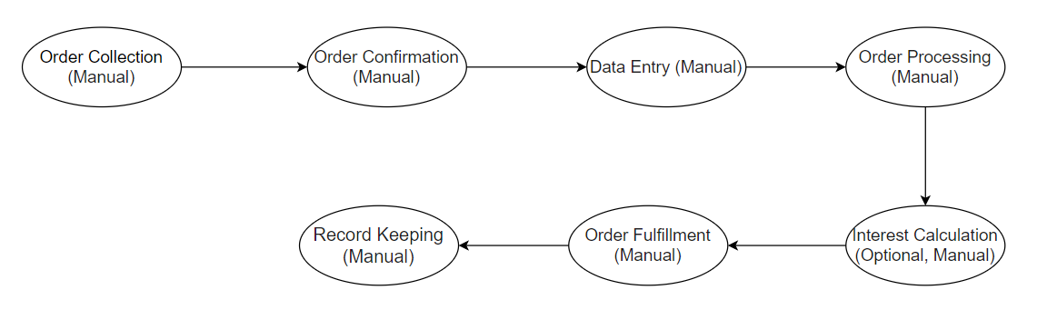

**4 Project summary**

*(50-200 words, includes aims, outcomes, significance and social and/or economic benefits for customers)*

Orderly is an innovative online shop management system designed to empower small and medium-sized businesses to **reclaim control and unlock their full potential**. By **streamlining order processing, inventory management, and customer communication**, Orderly empowers shop owners to **focus on growth strategies and deliver exceptional customer service**. This allows them to **compete effectively in the ever-evolving e-commerce landscape**.

**5 Significance and innovation**

*(Describe and detail the significance of the project and whether the project helps your customers to solve important problems. Consider the following questions:*

*Why undertake the project?*

*What is innovative about the system you are building?*

*What new methodologies or technologies will be developed?)*

Many online shops struggle with managing orders efficiently, leading to:

* Delays in order fulfillment
* Lost sales opportunities
* Frustrated customers and damaged brand reputation

Orderly addresses these challenges by **streamlining operations and reducing errors**:

* **Increased sales** through faster order processing and reduced cart abandonment.
* **Improved customer satisfaction** with a seamless ordering experience and efficient communication.
* **Cost savings** by minimizing operational inefficiencies.

Orderly utilizes cutting-edge technologies to provide a **unique and innovative solution**:

* **Customers can freely customize products:** Unlike e-commerce platforms as well as other order management apps, Orderly allows customers to design their own products via the web and thereby manage orders. to avoid confusion when producing and delivering products.

**6 Approach**

*(Describe the methodology / programming language / framework/ technologies… to be used ?)*

The system will be developed using a combination of:

* **Front-end technologies:** PHP, CSS, HTML
* **Back-end technologies:** PHP
* **Database:** MySQL

**7 Expected outcomes**

*(Describe the expected outcomes and likely impact of the proposed system (100-300 words))*

Orderly aims to deliver a **transformative experience** for both shop owners and customers:

**(i). One-Click Order Processing:**

* **Simplified order confirmation:** Customers can confirm their orders with a single click, eliminating the need to navigate through multiple pages and fill out lengthy forms. This **reduces checkout time** significantly, minimizing cart abandonment and **increasing conversion rates**.
* **Significantly increased processing speed:** By automating order confirmation, the system eliminates manual data entry and verification steps, leading to **faster order processing times**. This allows shop owners to fulfill orders quicker, **improve their efficiency**, and potentially offer faster shipping options to customers.

**(ii). Real-time Order Tracking:**

* **Instant order status updates:** Customers can track the progress of their orders in real-time, **eliminating the need to contact customer support for updates**. This **transparency** builds trust and **reduces customer anxiety**, leading to a more positive shopping experience.

**(iii). Improved Customer Satisfaction:**

* **Convenience and efficiency:** One-click ordering, pre-populated information, and real-time order tracking contribute to a **more convenient and efficient shopping experience**. This reduces friction points and **increases customer satisfaction**.
* **Reduced wait times:** Streamlined processes and faster order processing times **minimize wait times** for order confirmation and updates, leading to a **more positive customer experience**.
* **Enhanced communication:** Real-time order tracking **keeps customers informed and reduces the need for customer service inquiries**, fostering a **positive and transparent communication environment**.

**8 Description of personnel**

*(Summarize the role, responsibilities and contributions of each team member.)*

* **Business Analyst (BA):** Nguyễn Thị Hiền Anh, Nguyễn Thị Huyền Trang (Project Management)
  + **Responsibilities:** Analyzes business needs, defines functionalities, and acts as the bridge between stakeholders and developers.
  + **Contributions:** Ensures the system aligns with business objectives and user needs, facilitating clear communication, and defining success metrics.
* **Software Developer:** Lê Minh Nghĩa, Tạ Hoàng Hiệp
  + **Responsibilities:** Develops and implements system functionalities, ensures technical feasibility, writes clean code, and collaborates with BA and QA Tester.
  + **Contributions:** Transforms system requirements into a functioning application, ensures technical soundness, and maintains code documentation.
* **QA Tester:** Phạm Ngọc Thùy Nhung
  + **Responsibilities:** Designs and executes test cases, identifies and reports bugs, performs manual and automated testing, and participates in user acceptance testing.
  + **Contributions:** Identifies and mitigates potential issues, ensures high-quality user experience, and provides valuable feedback for continuous improvement.
* **Customers:**
  + **Role:** While not actively involved in development, their needs and feedback are crucial.
  + **Contribution:** The project aims to directly benefit customers through a seamless ordering experience. User testing will be conducted to ensure the system meets their expectations and delivers a positive shopping journey. This customer-centric approach guarantees Orderly becomes a valuable tool for both shop owners and their customers.